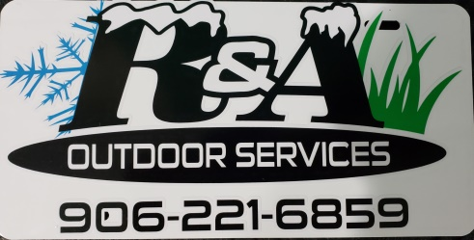

114 5th St.

Iron Mountain, MI 49801

December 1, 2024

Craig/ EGLE,

Good morning, We as a company have reached out to get information on how to become certified for Demolitions on commercial buildings for future. We have saved your information so we can contact you for further information needed on how to register the demo if it is Needed. We appreciate all of your assistance so far in this matter and we will be taking all necessary actions needed to be in compliance from here on out.

Any questions feel free to contact me at (906)221-6859.

Sincerely,

Andrew Waitrovich

R&A Outdoor Services