

Imlay City Police Department

**395 East Third St.**

**Imlay City, MI 48444**

**(810) 724-2345**

# MEMO November 6th, 2024

**To:** Mr. Craig Horton, City Manager, City of Imlay City

**Cc:** Mayor Barbara Yockey, Imlay City Commissioners

**From:** Chief of Police, Brett D. Selby

**Subject:** 400 E Third Street, Imlay City, Michigan 48444

Mr. Horton,

I would like to bring to your attention the conditions of a city owned property located at 400 E Third Street, Imlay City Michigan. I am in deep concern with the condition of the property and would deem the property as being an immediate public safety emergency. The building is in accelerated decay and the police department is concerned with the immediate health and safety of the citizens and nearby business owners and their customers.

Specifically, the walls of said property are caving in on all four sides and the corner mortis is severely splitting away from the building on the north east corner prompting an inevitable collapse hazard. The next-door strip mall customers disregard the “no parking” signs, posted “keep out” signs and even move physical barriers to park on the city property right in front of the below pictured wall that is severely cracking. Going forward, ticketing towing and impounding vehicles are the only recourse to preserve life and property and costly litigation.

On the front of the building of 400 E Third, there is an approximate 20 x 50 brick fascia above the front door which is severely leaning inward and the mortis is all but chipped out, cracked and at severe risk of falling back into the building.

To add to this, the entire roof has several large holes in it and the rubber bladder roof covering is exposing the interior of most of inside of the building to the elements.

It is my belief that the building is ultimately now “unsecurable” and will need to come down immediately to avoid personal injury or worse in the very near future. I am asking The Mayor, the city commission and yourself to begin the process to taking bids for demolition.

This property is structurally unsound and could collapse at any time and should be demolished as soon as possible.

Please see the below photos for relevant reference in this matter.

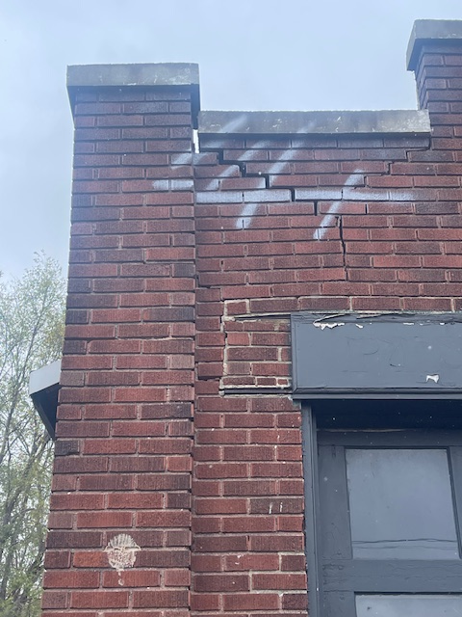

November 2024

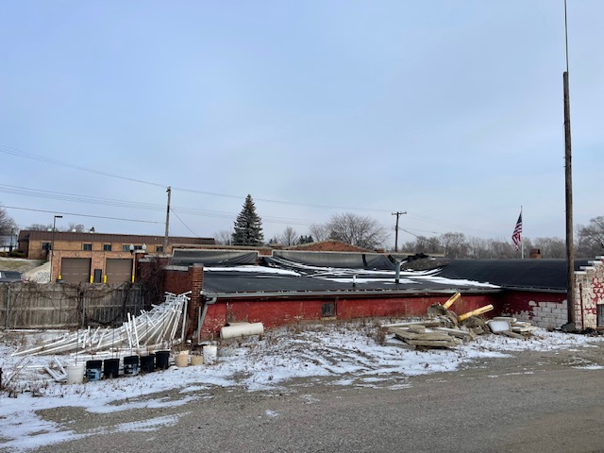

November 2024

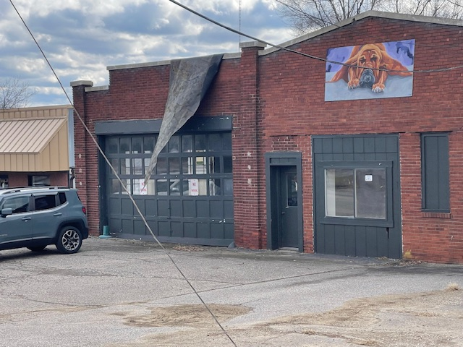

November 2024

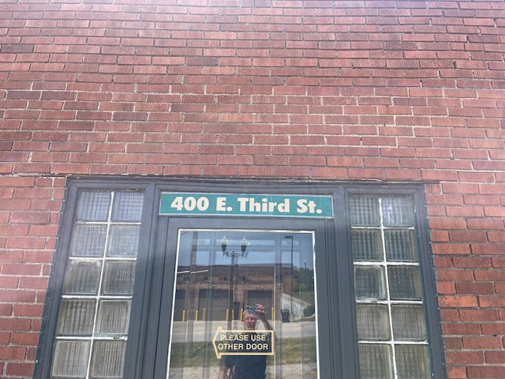

November 2024

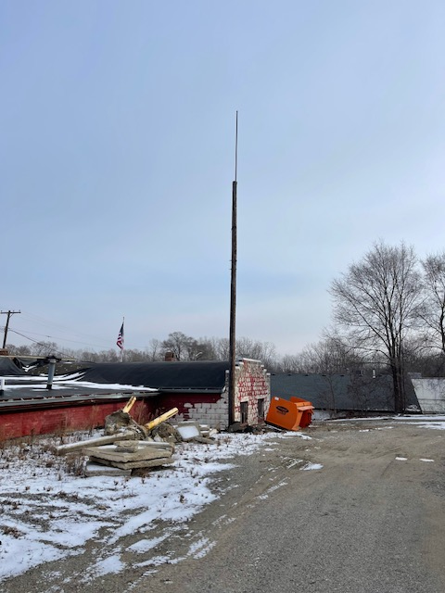

November 2024

Thank you in advance,



Brett D. Selby

Chief of Police

Imlay City Police Department