MALFUNCTION ABATEMENT PLAN

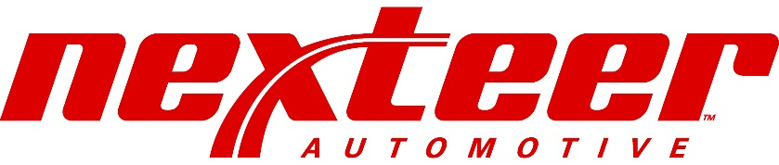

Nexteer Automotive Corporation 3900 Holland Road
Saginaw, Michigan 48601

April 2022

TABLE OF CONTENTS

1.0 Purpose 1
1.1 Purpose 1
1.2 Identification of Affected Sources 2
1.2.1 Process Emission Sources 2
1.2.2 Fuel Burning Emission Sources 2
1.2.3 Rule 290 Sources 3
1.3 Definition of Terms 3
2.0 Emission Source Startup and Shutdown 5
3.0 Malfunction Events 6
3.1 Identification of Malfunction Events 6
3.2 Response to Malfunction Events 6
3.2.1 Response to Process Source Malfunctions 6
3.2.2 Response to Fuel-Burning Source Malfunctions 6
3.3 Catastrophic Events and Loss of Utilities 8
4.0 Recordkeeping and Reporting Procedures 9
4.1 Recordkeeping 9
4.2 Reporting and Notification Requirements 9
4.2.1 Immediate Startup, Shutdown, & Malfunction Reports 9
4.2.2 Periodic Startup, Shutdown, & Malfunction Reports 9
5.0 Preventative Maintenance 10
6.0 Contact List 11

List of Appendices

Appendix A Process Emission Sources Appendix B Fuel Burning Emission Sources Appendix C Rule 290 Sources
Appendix D Malfunction Decision Matrix Appendix E MAP Log
Appendix F Environmental PM Process Flow Chart
Appendix G Sample PM Record Sheet Appendix H Contact Information

Purpose

Nexteer Automotive Corporation (Nexteer) is an automotive steering system component manufacturing facility located in Saginaw, Michigan. Nexteer consists of six manufacturing plants designated as Plants 1, 3, 4, 5, 6, and 7, and a Power House. The Nexteer facility contains both fuel- burning and process operations that are Michigan Department of Environmental, Great Lakes, and Energy (EGLE) permitted air emission sources. Emission control devices are utilized to abate potential air emissions from many of these sources. Nexteer was required by EGLE under the provisions of Renewable Operating Permit (ROP) No. MI-ROP-A6175-2022 (proposed revision year) and EGLE Regulation R336.1911 to prepare and submit a Malfunction Abatement Plan (MAP).

In October 2003, a MAP was prepared by Nexteer and submitted to EGLE. Subsequent revisions requested by EGLE were also provided in March 2006; August 22 & October 29, 2008, April 2011, June 2014 and January 2019. This update of the MAP has been developed to further streamline and clarify the previously submitted versions in keeping with the intent of the EGLE regulations as well as Nexteer’s own ISO 140001-certifed environmental management practices for continuing improvement.

Purpose

The purpose of the MAP is to identify the potential sources of excess air emissions and establish procedures to minimize excess emissions should they occur as the result of a Startup, Shutdown, Malfunction (SSM), or other abnormal condition (referred to as MAP events). The Nexteer MAP includes or references existing Nexteer operating and maintenance procedures in order to satisfy the following objectives:

    - Ensure that affected sources and associated air pollution control and monitoring equipment are properly operated and maintained at all times.

    - Ensure that air emissions are minimized as much as possible during SSM events provided the actions taken are consistent with good safety and air pollution control practices. The primary objective during these events will be to stay below applicable emission limitations during the MAP events in order to maintain continuing protection of the ambient air quality in and around the facility.

    - Ensure proper operation and maintenance during periods of SSM.

    - Provide corrective actions for malfunctioning processes or air pollution control equipment in order to comply with the relevant standard and thus ensure the return to normal operations as soon as practicable after the occurrence of an MAP event.

    - Provide oversight to MAP events and updates to the MAP as may be indicated by the assessment of actions taken during the MAP events.

    - Ensure proper recordkeeping and timely short term and long term reporting of MAP events. Short term reporting is required if a MAP event generates excess emissions. Long term reporting is required at least every six months regardless of the number of MAP events that may have occurred.

In summary, the purpose of this plan is to:

    - Ensure that affected sources and air pollution control and monitoring devices are operated and maintained in a manner consistent with good air pollution control practices at all times.
    - Ensure that malfunctions are corrected as soon as practicable after their occurrence. The plan will also identify recordkeeping and reporting requirements associated with periods of
SSM.

Identification of Affected Sources

Affected emission sources are the fuel-burning and permitted process equipment with associated emission control equipment as defined in Nexteer EGLE (ROP) MI-ROP-A6175- 2022 (proposed revision year). These include industrial natural gas-fired boilers; process sources including gas-fired furnaces, phoscoating; and various sanding, grinding, and other finishing equipment used for the manufacturing of steering components.

Process Emission Sources

Appendix A provides a table of the ROP-permitted process emission sources and their associated performance indicators and nominal operating ranges. The process emission sources (all ROP-listed sources exclusive of the boilers and other fuel burning emission sources) are equipped with emission control devices (scrubbers, mist collectors, or fabric filters), that are operated within the indicated pressure drop ranges in order to meet the level of emission control performance for each control device indicated by their respective manufacturers. Those performance levels are referenced in the Nexteer ROP in terms of emission limits expressed in pounds of emissions per 1,000 pounds of exhaust gas and adjusted to dry gas conditions or at specified percent excess air. The pressure drops are confirmed daily or monthly as required by the ROP. In addition, plant personnel monitor for any unusual process performance that might result in excess emissions. The pressure drops are confirmed, and the Maintenance Department is notified of any out-of-range pressure drops or other performance concerns. In addition, all process equipment and emission control devices are integrated into Nexteer’s preventative maintenance program, which allow detection and correction of the performance of the process sources and emission control devices before breakdowns can occur and generate excess emissions. Not all circumstances that could result in excess emissions can be predicted. In the rare instance that excess emissions are generated from a process source or its associated control device, the event will be addressed as an abnormal condition as indicated in the Nexteer MAP decision process.

Fuel Burning Emission Sources

Appendix B provides a table of the industrial boilers, furnaces, and a thermal deburring unit including emission control devices and relevant information regarding performance indicators
and nominal operating ranges. Nexteer operates a total of four (4) natural gas fired boilers.

Natural gas-fired devices and the thermal deburring unit that are not equipped with emission control devices would not generate excess emissions at startup or shutdown except for malfunctions in the burner devices or their associated operational controls.

Rule 290 Sources

Appendix C provides a listing of sources regulated under Rule 290 of the Michigan Air Pollution Control Rules and covered in this MAP.

Definition of Terms

The following terms are utilized in this MAP:

Startup
Startup is defined as the setting in operation of an affected source or portion of an affected source for any purpose.

Shutdown
Shutdown is defined as the cessation of operation of an affected source or portion of an affected source for any purpose.

Malfunction
Malfunction is defined as any sudden, infrequent, and not reasonably preventable failure of air pollution control equipment, air pollution monitoring equipment, or process equipment to operate in a normal or usual manner which causes, or has the potential to cause, the emission limitations in an applicable standard to be exceeded.

Excess Emissions
Excess emissions are defined as emissions in excess of a relative standard or permit emission limit that occur during a startup, shutdown, malfunction, or abnormal emissions event. Exceedances of emission limits or operating parameters that occur when actions taken are consistent with the MAP should not be considered violations.

Abnormal Condition
A sudden and not reasonably anticipated excess emissions event that occurs beyond the control of Nexteer personnel who are operating the affected equipment.

ROP
A Renewable Operating Permit issued by the EGLE.

MAP
Malfunction Abatement Plan

MAP Log
An official log maintained by the Environmental Department that includes an entry for each reportable SSM event and includes the following:
- the time of occurrence
- documentation of monitoring equipment maintained during the event (if possible)
- duration
- actions taken to minimize the impact
- the cause
- measures that will be taken to avoid repeat occurrences if at all possible

Emission Source Startup and Shutdown

No emission sources at Nexteer may be operated without their respective emission control devices. Natural gas-fired devices and the thermal deburring unit that are not equipped with emission control devices would not generate excess emissions at startup or shutdown except for malfunctions in the burner devices or their associated operational controls. Therefore, excess emissions at startup or shutdown for Nexteer emission sources are limited to equipment malfunctions or catastrophic conditions and will be addressed as indicated in the applicable sections of this plan.

Malfunction Events

Identification of Malfunction Events

Malfunction events generate a series of actions on the part of Nexteer personnel that are designed to minimize emissions by ensuring proper corrective actions are initiated as quickly as possible and ensure that required recordkeeping, notifications, and follow-up actions are facilitated.

A malfunction decision matrix was developed to guide Nexteer personnel in determining the nature of an event and the appropriate response to each malfunction or abnormal emissions event. The decision matrix leads Nexteer personnel to the appropriate responses to the event based on the nature of that event. It directs the necessary internal communications with the Maintenance and Environmental Departments, the record keeping associated with an event, and any external notifications that may be required. For specific emission units located in Plants 4 & 5, there is an alternative reaction plan for the maintenance staff to follow. The decision matrix and reaction plan are included in Appendix D.

Response to Malfunction Events

Response to Process Source Malfunctions

As indicated in Appendix A, each process source has an emission control device that is operated at all times during normal operation. Each has a performance indicator, normally a pressure drop across the control device, which is monitored on the schedule prescribed by the ROP. In addition, the process equipment and associated control devices are subject to preventative maintenance on an on-going schedule. In the event that an indication of abnormal operation of a process operation or its control device is observed by plant personnel, which may be out-of-range values of the control device performance indicator or a visual observation, the Maintenance Department is notified to request repairs as may be needed. Should an excess emission event be determined, the Environmental Department is notified as indicated by the decision matrix so that the necessary determinations can be made regarding the nature of the event and the need for any additional actions that may be required by the MAP.

Response to Fuel-Burning Source Malfunctions

Nexteer fuel-burning emission sources are comprised of natural gas-fired boilers and process sources. Natural gas-fired devices and the thermal deburring unit present little opportunity for excess emissions during normal operation. In those unlikely circumstances that an excess emission event occurred with a natural gas burning unit, it would be identified as an abnormal event and addressed as indicated in the decision matrix.

Excess emissions of other regulated pollutants will be necessarily controlled by the type and quantity of fuels used and would be a quality control problem rather than an abnormal emission event to be addressed under the MAP. Monitoring of compliance with these requirements is achieved through Nexteer’s on-going compliance monitoring and reporting requirements of the ROP and would not become an item addressed in the MAP unless an unacceptable quality fuel is provided to Nexteer or a boiler malfunction results in the use of an excess quantity of fuel. An appropriate response as a malfunction in those situations will be achieved as directed by the decision matrix.

Catastrophic Events and Loss of Utilities

Catastrophic events and loss of utilities beyond the control of Nexteer can occur that can lead to excess emissions despite proper due diligence on the part of Nexteer. Under such circumstances, Nexteer will undertake responsibility to shut down affected process and boiler emission sources as soon as practicable, as outlined in the site’s Infrastructure Contingency Plan, considering all factors possible to protect the safety and well-being of its employees and the surrounding community. Such situations will be considered beyond the realm of an MAP event but will be noted in MAP logs for future reference.

Recordkeeping and Reporting Procedures

In the event that an SSM event is verified, recordkeeping and reporting activities are identified by the MAP decision matrix that must be executed in keeping with Nexteer MAP procedures and in compliance with EGLE MAP requirements. Each is described in the following sections.

Recordkeeping

In the event that an SSM event is confirmed, the Nexteer Environmental Department will note the events in the MAP log (Appendix E) and ensure that required actions have been taken to repair the cause(s) of the event as expeditiously as practicable. The Nexteer Environmental Department will determine if immediate notifications to EGLE are required and make the appropriate notifications.

The Environmental Department will also determine what information on each event must be included on ensuing air emission reports as may be required under the Nexteer ROP.

The Environmental Department will perform a review of the history of recorded events in the MAP log for preparation of each periodic regulatory report in order to assess the nature and frequency at which MAP events may have occurred. The Environmental Department will notify Nexteer management should MAP events appear to be frequent or repetitive in nature so that action can be undertaken to avoid future recurrences of those events.

Reporting and Notification Requirements

Immediate Startup, Shutdown, & Malfunction Reports

As shown in the decision matrix, the Environmental Department will identify any immediate reporting required by the MAP and will in turn notify the EGLE. The Environmental Department will also notify Nexteer Management of any follow-up and/or written reports to EGLE required.

Periodic Startup, Shutdown, & Malfunction Reports

The Environmental Department will ensure that periodic SSM reports will accompany routine semi-annual, and other required reports to EGLE as required by the ROP and associated applicable requirements of EGLE and EPA.

Preventative Maintenance

Nexteer operates a formal Preventative Maintenance (PM) program that addresses equipment within the facility, including the emission units and associated emission control devices covered in this plan. Each unit is identified by a tag number and is assigned PM tasks at frequencies necessary to properly maintain the operation of that piece of equipment within normal operating parameters. Spare parts are maintained on site as needed to ensure proper operation and repair of the equipment. The Nexteer PM system maintains records of the assigned tasks and reports on the performance of those tasks.

Appendix F is Nexteer’s Environmental PM Process Flow Chart, which demonstrates how Nexteer’s environmental and PM systems are integrated to ensure that regulated emission sources are maintained on an on-going basis. This process also provides the Environmental Department with the information needed to evaluate the on-going operation of the regulated emission sources in order to identify and help prevent any chronic or frequently repeated performance issues.

An example PM record sheet is included as Appendix G to demonstrate how source equipment is identified, what parameters are tracked, and how the performance of PM is logged on an on-going basis.

Contact List

The MAP requires that extensive internal and external contacts be coordinated by the Environmental Department. To facilitate that, a contact list is maintained by the Environmental Department of individuals that must be contacted during emergency and routine activities associated with the implementation of the MAP. Appendix H provides a copy of the current contact list. The official list will be maintained in the Environmental Department and will be updated to reflect changes and additions necessary to ensure efficient operation and coordination of the MAP.

Appendix A

Process Emission Sources

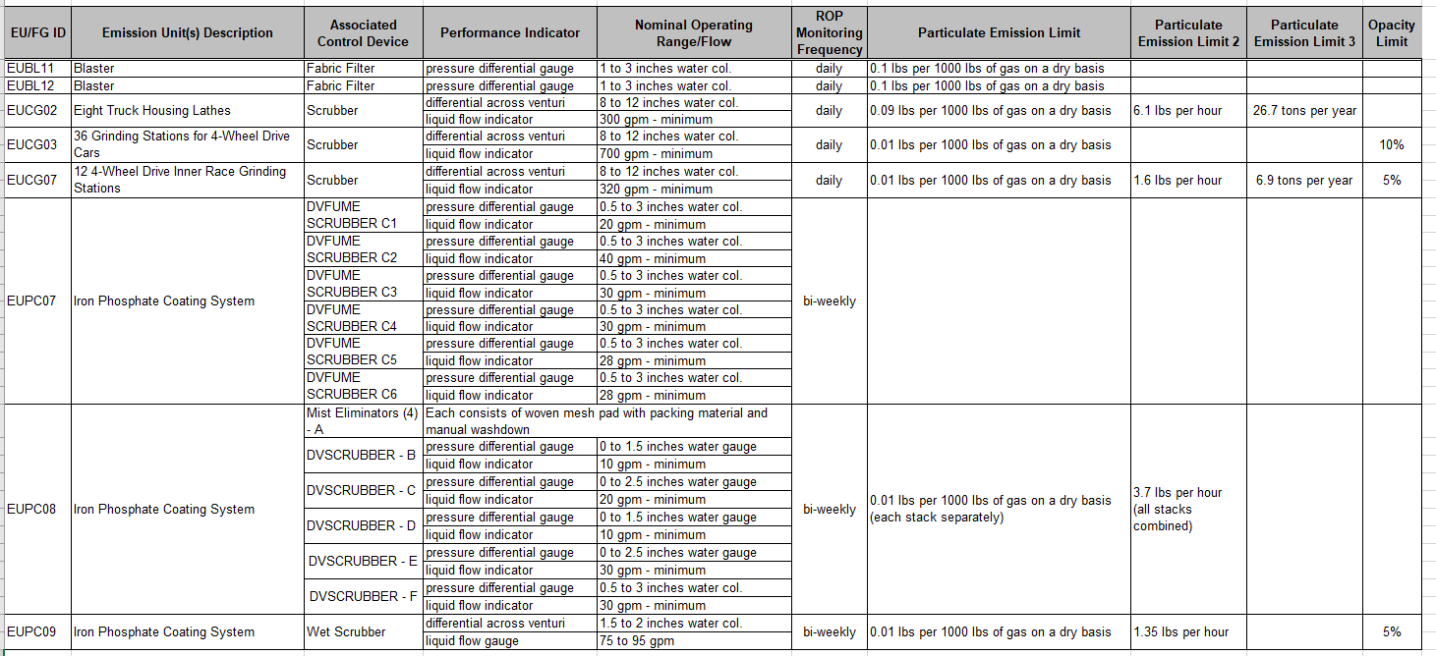

Appendix B

Fuel Burning Emission Sources

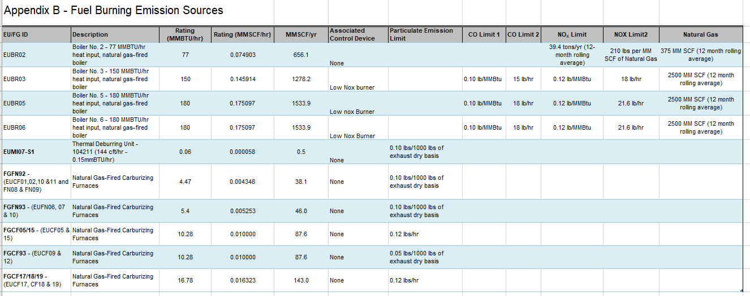

Appendix C

Rule290 Sources

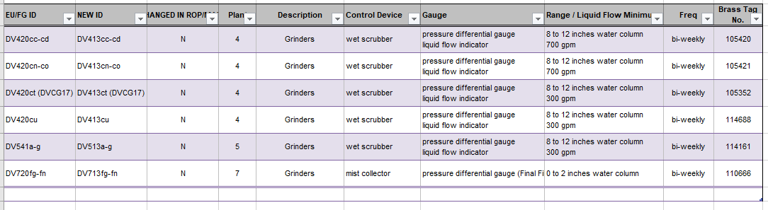

Appendix D

Malfunction Decision Matrix
&
Plants 4 & 5 Reaction Plan

Malfunction Decision Matrix Nexteer Automotive Corporation

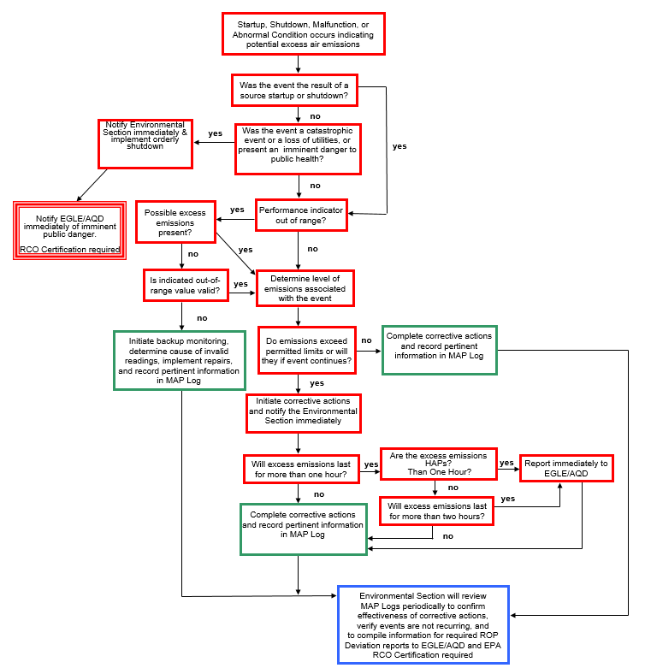

Plants 4 & 5 Reaction Plan
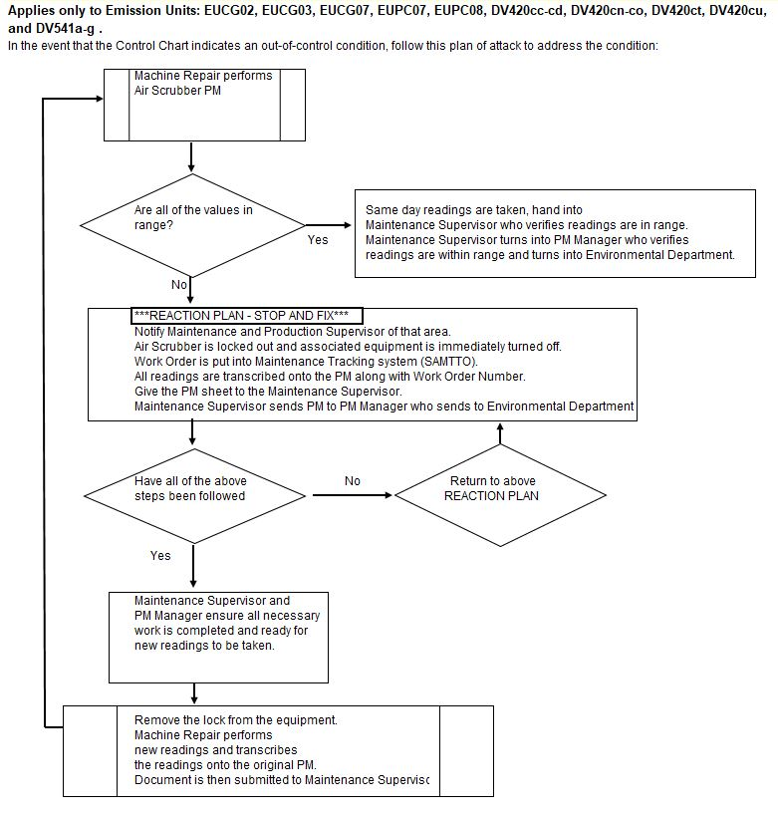

Appendix E

MAP Log

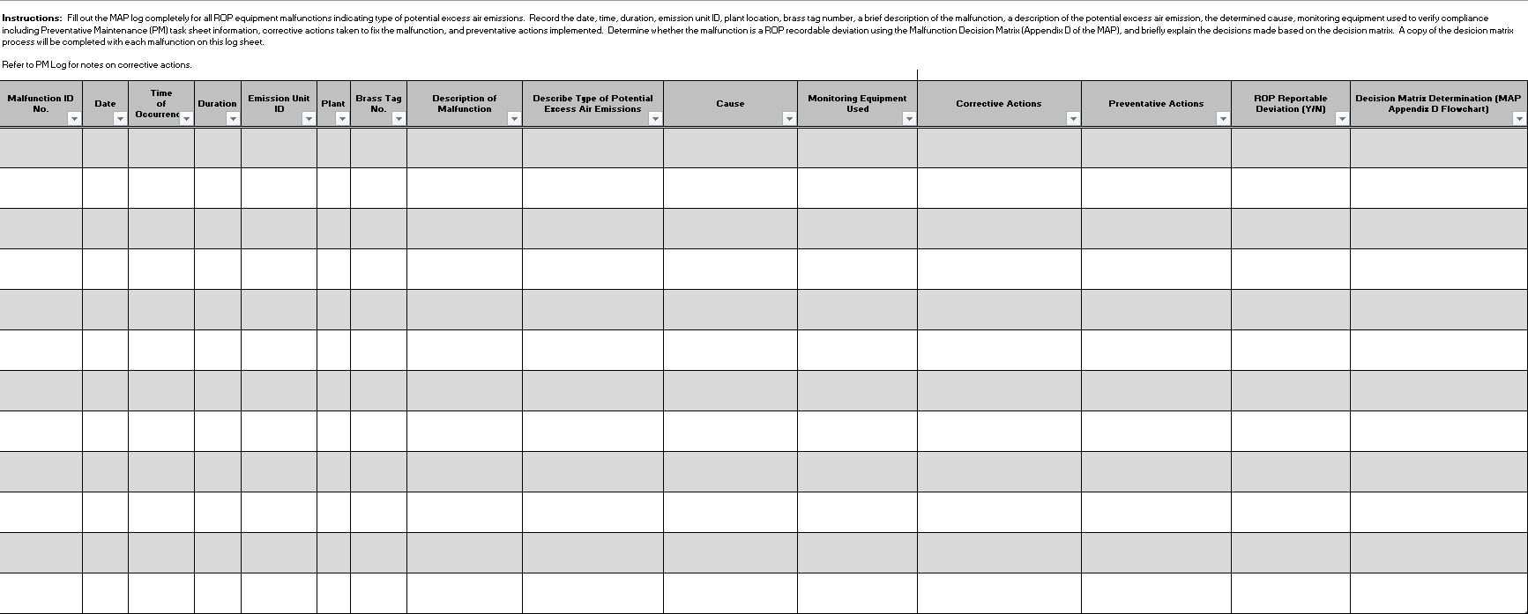

Appendix F

Environmental PM Process Flow Chart

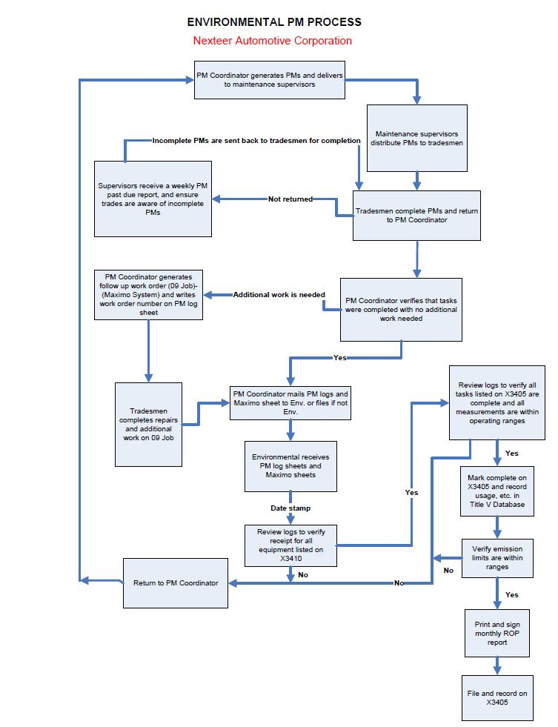

Appendix G

Sample PM Record Sheet

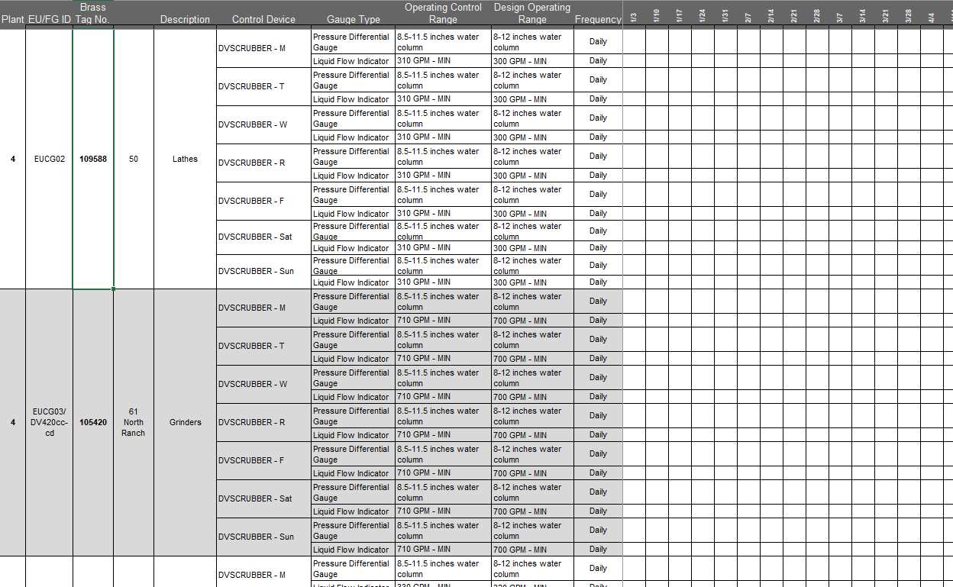

Appendix H
Contact Information

