MICHIGAN DEPARTMENT OF ENVIRONMENT, GREAT LAKES, AND ENERGY
AIR QUALITY DIVISION
EFFECTIVE DATE: June 27, 2022

ISSUED TO

Lyons Industries, Inc.

State Registration Number (SRN): N5599

LOCATED AT

30000 M-62 West, Dowagiac, Cass County, Michigan 49047
RENEWABLE OPERATING PERMIT

Permit Number: MI-ROP-N5599-2022

Expiration Date: June 27, 2027

Administratively Complete ROP Renewal Application Due Between
December 27, 2025 and December 27, 2026

This Renewable Operating Permit (ROP) is issued in accordance with and subject to Section 5506(3) of Part 55, Air Pollution Control, of the Natural Resources and Environmental Protection Act, 1994 PA 451, as amended (Act 451). Pursuant to Rule 210(1) of the administrative rules promulgated under Act 451, this ROP constitutes the permittee’s authority to operate the stationary source identified above in accordance with the general conditions, special conditions and attachments contained herein. Operation of the stationary source and all emission units listed in the permit are subject to all applicable future or amended rules and regulations pursuant to Act 451 and the federal Clean Air Act.

SOURCE-WIDE PERMIT TO INSTALL

Permit Number: MI-PTI-N5599-2022

This Permit to Install (PTI) is issued in accordance with and subject to Section 5505(1) of Act 451. Pursuant to Rule 214a of the administrative rules promulgated under Act 451, the terms and conditions herein, identified by the underlying applicable requirement citation of Rule 201(1)(a), constitute a federally enforceable PTI. The PTl terms and conditions do not expire and remain in effect unless the criteria of Rule 201(6) are met. Operation of all emission units identified in the PTI is subject to all applicable future or amended rules and regulations pursuant to Act 451 and the federal Clean Air Act.
Michigan Department of Environment, Great Lakes, and Energy

______________________________________
Rex Lane, Kalamazoo District Supervisor
TABLE OF CONTENTS

AUTHORITY AND ENFORCEABILITY 3
A. GENERAL CONDITIONS 4
Permit Enforceability 4
General Provisions 4
Equipment & Design 5
Emission Limits 5
Testing/Sampling 5
Monitoring/Recordkeeping 6
Certification & Reporting 6
Permit Shield 7
Revisions 8
Reopenings 8
Renewals 9
Stratospheric Ozone Protection 9
Risk Management Plan 9
Emission Trading 9
Permit to Install (PTI) 10
B. SOURCE-WIDE CONDITIONS 11
C. EMISSION UNIT SPECIAL CONDITIONS 12
EMISSION UNIT SUMMARY TABLE 12
EUDUSTCOLLECTOR 13
D. FLEXIBLE GROUP SPECIAL CONDITIONS 15
FLEXIBLE GROUP SUMMARY TABLE 15
FGBOOTHSUMMARY 16
FGNESHAP WWWW 19
FGNESHAP ZZZZ 23
E. NON-APPLICABLE REQUIREMENTS 26
APPENDICES 27
Appendix 1. Acronyms and Abbreviations 27
Appendix 2. Schedule of Compliance 28
Appendix 3. Monitoring Requirements 28
Appendix 4. Recordkeeping 28
Appendix 4A. UEF 29
Appendix 4B. Table 1 30
Appendix 4C. Table 2 32
Appendix 5. Testing Procedures 33
Appendix 6. Permits to Install 33
Appendix 7. Emission Calculations 33
Appendix 8. Reporting 33

AUTHORITY AND ENFORCEABILITY

For the purpose of this permit, the permittee is defined as any person who owns or operates an emission unit at a stationary source for which this permit has been issued. The department is defined in Rule 104(d) as the Director of the Michigan Department of Environment, Great Lakes, and Energy (EGLE) or his or her designee.

The permittee shall comply with all specific details in the permit terms and conditions and the cited underlying applicable requirements. All terms and conditions in this ROP are both federally enforceable and state enforceable unless otherwise footnoted. Certain terms and conditions are applicable to most stationary sources for which an ROP has been issued. These general conditions are included in Part A of this ROP. Other terms and conditions may apply to a specific emission unit, several emission units which are represented as a flexible group, or the entire stationary source which is represented as a Source-Wide group. Special conditions are identified in Parts B, C, D and/or the appendices.

In accordance with Rule 213(2)(a), all underlying applicable requirements are identified for each ROP term or condition. All terms and conditions that are included in a PTI are streamlined, subsumed and/or is state-only enforceable will be noted as such.

In accordance with Section 5507 of Act 451, the permittee has included in the ROP application a compliance certification, a schedule of compliance, and a compliance plan. For applicable requirements with which the source is in compliance, the source will continue to comply with these requirements. For applicable requirements with which the source is not in compliance, the source will comply with the detailed schedule of compliance requirements that are incorporated as an appendix in this ROP. Furthermore, for any applicable requirements effective after the date of issuance of this ROP, the stationary source will meet the requirements on a timely basis, unless the underlying applicable requirement requires a more detailed schedule of compliance.

Issuance of this permit does not obviate the necessity of obtaining such permits or approvals from other units of government as required by law.

A. GENERAL CONDITIONS

Permit Enforceability

- All conditions in this permit are both federally enforceable and state enforceable unless otherwise noted. (R 336.1213(5))

- Those conditions that are hereby incorporated in a state-only enforceable Source-Wide PTI pursuant to Rule 201(2)(d) are designated by footnote one. (R 336.1213(5)(a), R 336.1214a(5))

- Those conditions that are hereby incorporated in a federally enforceable Source-Wide PTI pursuant to Rule 201(2)(c) are designated by footnote two. (R 336.1213(5)(b), R 336.1214a(3))

General Provisions

- The permittee shall comply with all conditions of this ROP. Any ROP noncompliance constitutes a violation of Act 451, and is grounds for enforcement action, for ROP revocation or revision, or for denial of the renewal of the ROP. All terms and conditions of this ROP that are designated as federally enforceable are enforceable by the Administrator of the United States Environmental Protection Agency (USEPA) and by citizens under the provisions of the federal Clean Air Act (CAA). Any terms and conditions based on applicable requirements which are designated as “state-only” are not enforceable by the USEPA or citizens pursuant to the CAA. (R 336.1213(1)(a))

- It shall not be a defense for the permittee in an enforcement action that it would have been necessary to halt or reduce the permitted activity in order to maintain compliance with the conditions of this ROP. (R 336.1213(1)(b))

- This ROP may be modified, revised, or revoked for cause. The filing of a request by the permittee for a permit modification, revision, or termination, or a notification of planned changes or anticipated noncompliance does not stay any ROP term or condition. This does not supersede or affect the ability of the permittee to make changes, at the permittee’s own risk, pursuant to Rule 215 and Rule 216. (R 336.1213(1)(c))

- The permittee shall allow the department, or an authorized representative of the department, upon presentation of credentials and other documents as may be required by law and upon stating the authority for and purpose of the investigation, to perform any of the following activities: (R 336.1213(1)(d))
  - Enter, at reasonable times, a stationary source or other premises where emissions-related activity is conducted or where records must be kept under the conditions of the ROP.
  - Have access to and copy, at reasonable times, any records that must be kept under the conditions of the ROP.
  - Inspect, at reasonable times, any of the following:
    - Any stationary source.
    - Any emission unit.
    - Any equipment, including monitoring and air pollution control equipment.
    - Any work practices or operations regulated or required under the ROP.
  - As authorized by Section 5526 of Act 451, sample or monitor at reasonable times substances or parameters for the purpose of assuring compliance with the ROP or applicable requirements.

- The permittee shall furnish to the department, within a reasonable time, any information the department may request, in writing, to determine whether cause exists for modifying, revising, or revoking the ROP or to determine compliance with this ROP. Upon request, the permittee shall also furnish to the department copies of any records that are required to be kept as a term or condition of this ROP. For information which is claimed by the permittee to be confidential, consistent with the requirements of the 1976 PA 442, MCL §15.231 et seq., and known as the Freedom of Information Act, the person may also be required to furnish the records directly to the USEPA together with a claim of confidentiality. (R 336.1213(1)(e))

- A challenge by any person, the Administrator of the USEPA, or the department to a particular condition or a part of this ROP shall not set aside, delay, stay, or in any way affect the applicability or enforceability of any other condition or part of this ROP. (R 336.1213(1)(f))

- The permittee shall pay fees consistent with the fee schedule and requirements pursuant to Section 5522 of Act 451. (R 336.1213(1)(g))

- This ROP does not convey any property rights or any exclusive privilege. (R 336.1213(1)(h))

Equipment & Design

- Any collected air contaminants shall be removed as necessary to maintain the equipment at the required operating efficiency. The collection and disposal of air contaminants shall be performed in a manner so as to minimize the introduction of contaminants to the outer air. Transport of collected air contaminants in Priority I and II areas requires the use of material handling methods specified in Rule 370(2).² (R 336.1370)

- Any air cleaning device shall be installed, maintained, and operated in a satisfactory manner and in accordance with the Michigan Air Pollution Control rules and existing law. (R 336.1910)

Emission Limits

- Unless otherwise specified in this ROP, the permittee shall comply with Rule 301, which states, in part, “Except as provided in Subrules 2, 3, and 4 of this rule, a person shall not cause or permit to be discharged into the outer air from a process or process equipment a visible emission of a density greater than the most stringent of the following:”² (R 336.1301(1))
  - A 6-minute average of 20% opacity, except for one 6-minute average per hour of not more than 27% opacity.
  - A limit specified by an applicable federal new source performance standard.

The grading of visible emissions shall be determined in accordance with Rule 303.

- The permittee shall not cause or permit the emission of an air contaminant or water vapor in quantities that cause, alone or in reaction with other air contaminants, either of the following:
  - Injurious effects to human health or safety, animal life, plant life of significant economic value, or property.¹ (R 336.1901(a))
  - Unreasonable interference with the comfortable enjoyment of life and property.¹ (R 336.1901(b))

Testing/Sampling

- The department may require the owner or operator of any source of an air contaminant to conduct acceptable performance tests, at the owner’s or operator’s expense, in accordance with Rule 1001 and Rule 1003, under any of the conditions listed in Rule 1001(1).² (R 336.2001)

- Any required performance testing shall be conducted in accordance with Rule 1001(2), Rule 1001(3) and Rule 1003. (R 336.2001(2), R 336.2001(3), R 336.2003(1))

- Any required test results shall be submitted to the Air Quality Division (AQD) in the format prescribed by the applicable reference test method within 60 days following the last date of the test. (R 336.2001(5))

Monitoring/Recordkeeping

- Records of any periodic emission or parametric monitoring required in this ROP shall include the following information specified in Rule 213(3)(b)(i), where appropriate. (R 336.1213(3)(b))
  - The date, location, time, and method of sampling or measurements.
  - The dates the analyses of the samples were performed.
  - The company or entity that performed the analyses of the samples.
  - The analytical techniques or methods used.
  - The results of the analyses.
  - The related process operating conditions or parameters that existed at the time of sampling or measurement.

- All required monitoring data, support information and all reports, including reports of all instances of deviation from permit requirements, shall be kept and furnished to the department upon request for a period of not less than 5 years from the date of the monitoring sample, measurement, report or application. Support information includes all calibration and maintenance records and all original strip-chart recordings, or other original data records, for continuous monitoring instrumentation and copies of all reports required by the ROP. (R 336.1213(1)(e), R 336.1213(3)(b)(ii))

Certification & Reporting

- Except for the alternate certification schedule provided in Rule 213(3)(c)(iii)(B), any document required to be submitted to the department as a term or condition of this ROP shall contain an original certification by a Responsible Official which state that, based on information and belief formed after reasonable inquiry, the statements and information in the document are true, accurate, and complete. (R 336.1213(3)(c))

- A Responsible Official shall certify to the appropriate AQD District Office and to the USEPA that the stationary source is and has been in compliance with all terms and conditions contained in the ROP except for deviations that have been or are being reported to the appropriate AQD District Office pursuant to Rule 213(3)(c). This certification shall include all the information specified in Rule 213(4)(c)(i) through (v) and shall state that, based on information and belief formed after reasonable inquiry, the statements and information in the certification are true, accurate, and complete. The USEPA address is: USEPA, Air Compliance Data - Michigan, Air and Radiation Division, 77 West Jackson Boulevard, Chicago, Illinois 60604-3507. (R 336.1213(4)(c))

- The certification of compliance shall be submitted annually for the term of this ROP as detailed in the special conditions, or more frequently if specified in an applicable requirement or in this ROP. (R 336.1213(4)(c))

- The permittee shall promptly report any deviations from ROP requirements and certify the reports. The prompt reporting of deviations from ROP requirements is defined in Rule 213(3)(c)(ii) as follows, unless otherwise described in this ROP. (R 336.1213(3)(c))
  - For deviations that exceed the emissions allowed under the ROP, prompt reporting means reporting consistent with the requirements of Rule 912 as detailed in Condition 25. All reports submitted pursuant to this paragraph shall be promptly certified as specified in Rule 213(3)(c)(iii).
  - For deviations which exceed the emissions allowed under the ROP and which are not reported pursuant to Rule 912 due to the duration of the deviation, prompt reporting means the reporting of all deviations in the semiannual reports required by Rule 213(3)(c)(i). The report shall describe reasons for each deviation and the actions taken to minimize or correct each deviation.
  - For deviations that do not exceed the emissions allowed under the ROP, prompt reporting means the reporting of all deviations in the semiannual reports required by Rule 213(3)(c)(i). The report shall describe the reasons for each deviation and the actions taken to minimize or correct each deviation.

- For reports required pursuant to Rule 213(3)(c)(ii), prompt certification of the reports is described in Rule 213(3)(c)(iii) as either of the following: (R 336.1213(3)(c))
  - Submitting a certification by a Responsible Official with each report which states that, based on information and belief formed after reasonable inquiry, the statements and information in the report are true, accurate, and complete.
  - Submitting, within 30 days following the end of a calendar month during which one or more prompt reports of deviations from the emissions allowed under the ROP were submitted to the department pursuant to Rule 213(3)(c)(ii), a certification by a Responsible Official which states that; “based on information and belief formed after reasonable inquiry, the statements and information contained in each of the reports submitted during the previous month were true, accurate, and complete.” The certification shall include a listing of the reports that are being certified. Any report submitted pursuant to Rule 213(3)(c)(ii) that will be certified on a monthly basis pursuant to this paragraph shall include a statement that certification of the report will be provided within 30 days following the end of the calendar month.

- Semiannually for the term of the ROP as detailed in the special conditions, or more frequently if specified, the permittee shall submit certified reports of any required monitoring to the appropriate AQD District Office. All instances of deviations from ROP requirements during the reporting period shall be clearly identified in the reports. (R 336.1213(3)(c)(i))

- On an annual basis, the permittee shall report the actual emissions, or the information necessary to determine the actual emissions, of each regulated air pollutant as defined in Rule 212(6) for each emission unit utilizing the emissions inventory forms provided by the department. (R 336.1212(6))

- The permittee shall provide notice of an abnormal condition, start-up, shutdown, or malfunction that results in emissions of a hazardous or toxic air pollutant which continue for more than one hour in excess of any applicable standard or limitation, or emissions of any air contaminant continuing for more than two hours in excess of an applicable standard or limitation, as required in Rule 912, to the appropriate AQD District Office. The notice shall be provided not later than two business days after the start-up, shutdown, or discovery of the abnormal conditions or malfunction. Notice shall be by any reasonable means, including electronic, telephonic, or oral communication. Written reports, if required under Rule 912, must be submitted to the appropriate AQD District Supervisor within 10 days after the start-up or shutdown occurred, within 10 days after the abnormal conditions or malfunction has been corrected, or within 30 days of discovery of the abnormal conditions or malfunction, whichever is first. The written reports shall include all of the information required in Rule 912(5) and shall be certified by a Responsible Official in a manner consistent with the CAA.² (R 336.1912)

Permit Shield

- Compliance with the conditions of the ROP shall be considered compliance with any applicable requirements as of the date of ROP issuance if either of the following provisions is satisfied. (R 336.1213(6)(a)(i), R 336.1213(6)(a)(ii))
  - The applicable requirements are included and are specifically identified in the ROP.
  - The permit includes a determination or concise summary of the determination by the department that other specifically identified requirements are not applicable to the stationary source.

                - Any requirements identified in Part E of this ROP have been identified as non-applicable to this ROP and are included in the permit shield.

- Nothing in this ROP shall alter or affect any of the following:
  - The provisions of Section 303 of the CAA, emergency orders, including the authority of the USEPA under Section 303 of the CAA. (R 336.1213(6)(b)(i))
  - The liability of the owner or operator of this source for any violation of applicable requirements prior to or at the time of this ROP issuance. (R 336.1213(6)(b)(ii))
  - The applicable requirements of the acid rain program, consistent with Section 408(a) of the CAA. (R 336.1213(6)(b)(iii))

  - The ability of the USEPA to obtain information from a source pursuant to Section 114 of the CAA. (R 336.1213(6)(b)(iv))

- The permit shield shall not apply to provisions incorporated into this ROP through procedures for any of the following:
  - Operational flexibility changes made pursuant to Rule 215. (R 336.1215(5))
  - Administrative Amendments made pursuant to Rule 216(1)(a)(i)-(iv). (R 336.1216(1)(b)(iii))
  - Administrative Amendments made pursuant to Rule 216(1)(a)(v) until the amendment has been approved by the department. (R 336.1216(1)(c)(iii))
  - Minor Permit Modifications made pursuant to Rule 216(2). (R 336.1216(2)(f))
  - State-Only Modifications made pursuant to Rule 216(4) until the changes have been approved by the department. (R 336.1216(4)(e))

- Expiration of this ROP results in the loss of the permit shield. If a timely and administratively complete application for renewal is submitted not more than 18 months, but not less than 6 months, before the expiration date of the ROP, but the department fails to take final action before the end of the ROP term, the existing ROP does not expire until the renewal is issued or denied, and the permit shield shall extend beyond the original ROP term until the department takes final action. (R 336.1217(1)(c), R 336.1217(1)(a))

Revisions

- For changes to any process or process equipment covered by this ROP that do not require a revision of the ROP pursuant to Rule 216, the permittee must comply with Rule 215. (R 336.1215, R 336.1216)

- A change in ownership or operational control of a stationary source covered by this ROP shall be made pursuant to Rule 216(1). (R 336.1219(2))

- For revisions to this ROP, an administratively complete application shall be considered timely if it is received by the department in accordance with the time frames specified in Rule 216. (R 336.1210(10))

- Pursuant to Rule 216(1)(b)(iii), Rule 216(2)(d) and Rule 216(4)(d), after a change has been made, and until the department takes final action, the permittee shall comply with both the applicable requirements governing the change and the ROP terms and conditions proposed in the application for the modification. During this time period, the permittee may choose to not comply with the existing ROP terms and conditions that the application seeks to change. However, if the permittee fails to comply with the ROP terms and conditions proposed in the application during this time period, the terms and conditions in the ROP are enforceable. (R 336.1216(1)(c)(iii), R 336.1216(2)(d), R 336.1216(4)(d))

Reopenings

- A ROP shall be reopened by the department prior to the expiration date and revised by the department under any of the following circumstances:
  - If additional requirements become applicable to this stationary source with three or more years remaining in the term of the ROP, but not if the effective date of the new applicable requirement is later than the ROP expiration date. (R 336.1217(2)(a)(i))
  - If additional requirements pursuant to Title IV of the CAA become applicable to this stationary source. (R 336.1217(2)(a)(ii))
  - If the department determines that the ROP contains a material mistake, information required by any applicable requirement was omitted, or inaccurate statements were made in establishing emission limits or the terms or conditions of the ROP. (R 336.1217(2)(a)(iii))
  - If the department determines that the ROP must be revised to ensure compliance with the applicable requirements. (R 336.1217(2)(a)(iv))

Renewals

- For renewal of this ROP, an administratively complete application shall be considered timely if it is received by the department not more than 18 months, but not less than 6 months, before the expiration date of the ROP. (R 336.1210(9))

Stratospheric Ozone Protection

- If the permittee is subject to Title 40 of the Code of Federal Regulations (CFR), Part 82 and services, maintains, or repairs appliances except for motor vehicle air conditioners (MVAC), or disposes of appliances containing refrigerant, including MVAC and small appliances, or if the permittee is a refrigerant reclaimer, appliance owner or a manufacturer of appliances or recycling and recovery equipment, the permittee shall comply with all applicable standards for recycling and emissions reduction pursuant to 40 CFR Part 82, Subpart F.

- If the permittee is subject to 40 CFR Part 82 and performs a service on motor (fleet) vehicles when this service involves refrigerant in the MVAC, the permittee is subject to all the applicable requirements as specified in 40 CFR Part 82, Subpart B, Servicing of Motor Vehicle Air Conditioners. The term “motor vehicle” as used in Subpart B does not include a vehicle in which final assembly of the vehicle has not been completed by the original equipment manufacturer. The term MVAC as used in Subpart B does not include the air-tight sealed refrigeration system used for refrigerated cargo or an air conditioning system on passenger buses using Hydrochlorofluorocarbon-22 refrigerant.

Risk Management Plan

- If subject to Section 112(r) of the CAA and 40 CFR Part 68, the permittee shall register and submit to the USEPA the required data related to the risk management plan for reducing the probability of accidental releases of any regulated substances listed pursuant to Section 112(r)(3) of the CAA as amended in 40 CFR 68.130. The list of substances, threshold quantities, and accident prevention regulations promulgated under 40 CFR Part 68, do not limit in any way the general duty provisions under Section 112(r)(1).

- If subject to Section 112(r) of the CAA and 40 CFR Part 68, the permittee shall comply with the requirements of 40 CFR Part 68, no later than the latest of the following dates as provided in 40 CFR 68.10(a):
  - June 21, 1999,
  - Three years after the date on which a regulated substance is first listed under 40 CFR 68.130, or
  - The date on which a regulated substance is first present above a threshold quantity in a process.

- If subject to Section 112(r) of the CAA and 40 CFR Part 68, the permittee shall submit any additional relevant information requested by any regulatory agency necessary to ensure compliance with the requirements of 40 CFR Part 68.

- If subject to Section 112(r) of the CAA and 40 CFR Part 68, the permittee shall annually certify compliance with all applicable requirements of Section 112(r) as detailed in Rule 213(4)(c)). (40 CFR Part 68)

Emission Trading

- Emission averaging and emission reduction credit trading are allowed pursuant to any applicable interstate or regional emission trading program that has been approved by the Administrator of the USEPA as a part of Michigan’s State Implementation Plan. Such activities must comply with Rule 215 and Rule 216. (R 336.1213(12))

Permit to Install (PTI)

- The process or process equipment included in this permit shall not be reconstructed, relocated, or modified unless a PTI authorizing such action is issued by the department, except to the extent such action is exempt from the PTI requirements by any applicable rule.² (R 336.1201(1))

- The department may, after notice and opportunity for a hearing, revoke PTI terms or conditions if evidence indicates the process or process equipment is not performing in accordance with the terms and conditions of the PTI or is violating the department’s rules or the CAA.² (R 336.1201(8), Section 5510 of Act 451)

- The terms and conditions of a PTI shall apply to any person or legal entity that now or hereafter owns or operates the process or process equipment at the location authorized by the PTI. If a new owner or operator submits a written request to the department pursuant to Rule 219 and the department approves the request, this PTI will be amended to reflect the change of ownership or operational control. The request must include all of the information required by Subrules (1)(a), (b) and (c) of Rule 219. The written request shall be sent to the appropriate AQD District Supervisor, EGLE.² (R 336.1219)

- If the installation, reconstruction, relocation, or modification of the equipment for which PTI terms and conditions have been approved has not commenced within 18 months of the original PTI issuance date, or has been interrupted for 18 months, the applicable terms and conditions from that PTI, as incorporated into the ROP, shall become void unless otherwise authorized by the department. Furthermore, the person to whom that PTI was issued, or the designated authorized agent, shall notify the department via the Supervisor, Permit Section, EGLE, AQD, P. O. Box 30260, Lansing, Michigan 48909, if it is decided not to pursue the installation, reconstruction, relocation, or modification of the equipment allowed by the terms and conditions from that PTI.² (R 336.1201(4))

Footnotes:
¹This condition is state-only enforceable and was established pursuant to Rule 201(1)(b).
²This condition is federally enforceable and was established pursuant to Rule 201(1)(a).

B. SOURCE-WIDE CONDITIONS

Part B outlines the Source-Wide Terms and Conditions that apply to this stationary source. The permittee is subject to these special conditions for the stationary source in addition to the general conditions in Part A and any other terms and conditions contained in this ROP.

The permittee shall comply with all specific details in the special conditions and the underlying applicable requirements cited. If a specific condition type does not apply to this source, NA (not applicable) has been used in the table. If there are no Source-Wide Conditions, this section will be left blank.

C. EMISSION UNIT SPECIAL CONDITIONS

Part C outlines terms and conditions that are specific to individual emission units listed in the Emission Unit Summary Table. The permittee is subject to the special conditions for each emission unit in addition to the General Conditions in Part A and any other terms and conditions contained in this ROP.

The permittee shall comply with all specific details in the special conditions and the underlying applicable requirements cited. If a specific condition type does not apply, NA (not applicable) has been used in the table. If there are no conditions specific to individual emission units, this section will be left blank.

EMISSION UNIT SUMMARY TABLE
The descriptions provided below are for informational purposes and do not constitute enforceable conditions.

Emission Unit ID | Emission Unit Description  (Including Process Equipment & Control Device(s)) | Installation  Date/  Modification Date | Flexible Group ID
EUACRBOOTH1 | Booth used for gel coat spray or fiberglass lay-up operations. | 01-01-1995 | FGBOOTHSUMMARY FGNESHAP WWWW
EUGELBOOTH | Booth used for gel coat spray or fiberglass lay-up operations. | 03-01-1997 | FGBOOTHSUMMARY FGNESHAP WWWW
EUDUSTCOLLECTOR | Grinders, floor sweeps, and saws connected to outside dust collector. | 02-08-2008 | NA
EUGENERATOR | 1,135 BHP (2.98 MMBTU/hr) #2 diesel fired compression ignition emergency generator. | 2015 | FGNESHAP ZZZZ

EUDUSTCOLLECTOR
EMISSION UNIT CONDITIONS

DESCRIPTION

Grinders, floor sweeps, and saws connected to outside dust collector.

Flexible Group ID: NA

POLLUTION CONTROL EQUIPMENT

Dust Collector

I. EMISSION LIMIT(S)

Pollutant | Limit | Time Period/ Operating Scenario | Equipment | Monitoring/  Testing Method | Underlying Applicable Requirements
- PM | 0.1 lb/1000 lbs exhaust gas, on a dry gas basis | Hourly | EUDUSTCOLLECTOR | SC V.1  SC VI.1 | R 336.1331(1)(a), Table 31(J)

II. MATERIAL LIMIT(S)

NA

III. PROCESS/OPERATIONAL RESTRICTION(S)

NA

IV. DESIGN/EQUIPMENT PARAMETER(S)

- An air-cleaning device shall be installed, maintained, and operated in a satisfactory manner and in accordance with these rules and existing law. (R 336.1910)

- Collected air contaminants shall be removed as necessary to maintain the equipment at the required operating efficiency. The collection and disposal of air contaminants shall be performed in a manner so as to minimize the introduction of contaminants to the outer air. (R 336.1370(1))

V. TESTING/SAMPLING
Records shall be maintained on file for a period of five years. (R 336.1213(3)(b)(ii))

- Upon request of the AQD District Supervisor, the permittee shall verify PM emission rates from EUDUSTCOLLECTOR by testing at the owner’s expense, in accordance with the Department requirements. Testing shall be performed using an approved USEPA Method listed in 40 CFR Part 60, Appendix A; Part 10 of the Michigan Air Pollution Control Rules. An alternate method, or a modification to the approved USEPA Method, may be specified in an AQD-approved Test Protocol and must meet the requirements of the federal Clean Air Act, all applicable state and federal rules and regulations, and be within the authority of the AQD to make the change. If testing is to be performed, no less than 30 days prior to testing, the permittee shall submit a complete test plan to the AQD Technical Programs Unit and District Office. The AQD must approve the final plan prior to testing, including any modifications to the method in the test protocol that are proposed after initial submittal. The permittee must submit a complete report of the test results to the AQD Technical Programs Unit and District Office within 60 days following the last date of the test. (R 336.1213(3), R 336.2001, R 336.2003, R 336.2004)

- The permittee shall notify the AQD Technical Programs Unit Supervisor and the District Supervisor not less than 30 days before testing of the time and place performance tests will be conducted. (R 336.1213(3))

VI. MONITORING/RECORDKEEPING
Records shall be maintained on file for a period of five years. (R 336.1213(3)(b)(ii))

- The permittee shall perform a daily inspection of the dust collector including a visual emissions check for those days the facility is operating. (R 336.1213(3))

VII. REPORTING

1. Prompt reporting of deviations pursuant to General Conditions 21 and 22 of Part A. (R 336.1213(3)(c)(ii))

2. Semiannual reporting of monitoring and deviations pursuant to General Condition 23 of Part A. The report shall be postmarked or received by the appropriate AQD District Office by March 15 for reporting period July 1 to December 31 and September 15 for reporting period January 1 to June 30. (R 336.1213(3)(c)(i))

3. Annual certification of compliance pursuant to General Conditions 19 and 20 of Part A. The report shall be postmarked or received by the appropriate AQD District Office by March 15 for the previous calendar year. (R 336.1213(4)(c))

- The permittee shall submit any performance test reports to the AQD Technical Programs Unit and District Office, in a format approved by the AQD. (R 336.1213(3)(c), R 336.2001(5))

See Appendix 8

VIII. STACK/VENT RESTRICTION(S)

NA

IX. OTHER REQUIREMENT(S)

NA

Footnotes:
¹ This condition is state only enforceable and was established pursuant to Rule 201(1)(b).
² This condition is federally enforceable and was established pursuant to Rule 201(1)(a).

D. FLEXIBLE GROUP SPECIAL CONDITIONS

Part D outlines the terms and conditions that apply to more than one emission unit. The permittee is subject to the special conditions for each flexible group in addition to the General Conditions in Part A and any other terms and conditions contained in this ROP.

The permittee shall comply with all specific details in the special conditions and the underlying applicable requirements cited. If a specific condition type does not apply, NA (not applicable) has been used in the table. If there are no special conditions that apply to more than one emission unit, this section will be left blank.

FLEXIBLE GROUP SUMMARY TABLE
The descriptions provided below are for informational purposes and do not constitute enforceable conditions.

Flexible Group ID | Flexible Group Description | Associated  Emission Unit IDs
FGBOOTHSUMMARY | Gel coat spray and fiberglass lay-up operations. | EUACRBOOTH1  EUGELBOOTH
FGNESHAP WWWW | All equipment at the stationary source involved in reinforced plastic composites production that is identified as part of an EXISTING EFFECTED SOURCE subject to 40 CFR 63.5785 and 40 CFR 63.5790. | EUACRBOOTH1  EUGELBOOTH
FGNESHAP ZZZZ | New stationary emergency engines >500 BHP. 1,135 BHP (2.89 MMBTU/hr) #2 diesel fired compression ignition emergency generator. | EUGENERATOR

FGBOOTHSUMMARY
FLEXIBLE GROUP CONDITIONS

DESCRIPTION

Gel coat spray and fiberglass lay-up operations.

Emission Units: EUACRBOOTH1, EUGELBOOTH

POLLUTION CONTROL EQUIPMENT

Fabric filters

I. EMISSION LIMIT(S)

Pollutant | Limit | Time Period/Operating Scenario | Equipment | Monitoring/  Testing Method | Underlying Applicable Requirements
- VOC | 124.2 pounds per hour¹ | Calculated on a monthly basis | EUARCBOOTH1  EUGELBOOTH | SC VI.1 | R 336.1225
- VOC | 98.5 tons per year² | Based on a 12-month rolling time period as determined at the end of each calendar month | EUARCBOOTH1  EUGELBOOTH | SC VI.1 | R 336.1702(a)
- Styrene | 123.9 pounds per hour¹ | Calculated on a monthly basis | EUARCBOOTH1  EUGELBOOTH | SC VI.1 | R 336.1225
- Styrene | 98.2 tons per year¹ | Based on a 12-month rolling time period as determined at the end of each calendar month | EUARCBOOTH1  EUGELBOOTH | SC VI.1 | R 336.1225
- Acetone | 40 pounds per hour¹ | Calculated on a monthly basis | EUARCBOOTH1  EUGELBOOTH | SC VI.1 | R 336.1225
- Acetone | 29.75 tons per year¹ | Based on a 12-month rolling time period as determined at the end of each calendar month | EUARCBOOTH1  EUGELBOOTH | SC VI.1 | R 336.1225

II. MATERIAL LIMIT(S)

NA

III. PROCESS/OPERATIONAL RESTRICTION(S)

- The permittee shall change the dry filters in the booths when the differential pressure readings are outside the range specified by the manufacturer and/or the visual capture efficiency inspection concludes that inadequate capture efficiency is taking place. (R 336.1213(3))

IV. DESIGN/EQUIPMENT PARAMETER(S)

- The permittee shall equip and maintain all booths with HVLP spray guns or equivalent technology having comparable transfer efficiency. All applications shall be properly installed, maintained, and operated according to the manufacturer’s specifications.² (R 336.1225, R 336.1702a))

- All waste resins, gel coats, catalysts, and acetone shall be captured and stored in closed containers and disposed of in an acceptable manner in compliance with all applicable state rules and federal regulations.² (R 336.1370)

V. TESTING/SAMPLING
Records shall be maintained on file for a period of five years. (R 336.1213(3)(b)(ii))

NA

VI. MONITORING/RECORDKEEPING
Records shall be maintained on file for a period of five years. (R 336.1213(3)(b)(ii))

- The permittee shall maintain the following records and emission calculations:² (R 336.1702(a))
  - The identity of each resin, gel coat, catalyst, purge, and cleanup solvent used.
  - The composition in weight percent of VOC, free styrene, and acetone in each resin, gel coat, catalyst, purge, and cleanup solvent used.
  - The monthly operating hours.
  - The monthly and 12-month rolling time period total usage, in pounds, for each resin, gel coat, catalyst, purge, and cleanup solvent used.
  - The monthly and 12-month rolling time period reclaimed amount, in pounds, of purge and cleanup solvent.
  - The calculated monthly and 12-month rolling time period total mass VOC emissions, in pounds or tons.
  - The calculated monthly and 12-month rolling time period total mass styrene emissions, in pounds or tons.
  - The calculated monthly and 12-month rolling time period total mass acetone emissions, in pounds or tons.

- Perform visual installation and capture efficiency inspections of each of the particulate filters on a daily basis during maximum routine operating conditions (see Appendix 3). (R 336.1213(3))

- Monitor and record the differential pressure readings across each of the particulate filters on a daily basis, during maximum routine operating conditions. (R 336.1213(3))

See Appendices 3, 4, and 7

VII. REPORTING

1. Prompt reporting of deviations pursuant to General Conditions 21 and 22 of Part A. (R 336.1213(3)(c)(ii))

2. Semiannual reporting of monitoring and deviations pursuant to General Condition 23 of Part A. The report shall be postmarked or received by the appropriate AQD District Office by March 15 for reporting period July 1 to December 31 and September 15 for reporting period January 1 to June 30. (R 336.1213(3)(c)(i))

3. Annual certification of compliance pursuant to General Conditions 19 and 20 of Part A. The report shall be postmarked or received by the appropriate AQD District Office by March 15 for the previous calendar year. (R 336.1213(4)(c))

See Appendix 8

VIII. STACK/VENT RESTRICTION(S)

The exhaust gases from the stacks listed in the table below shall be discharged unobstructed vertically upwards to the ambient air unless otherwise noted:

Stack & Vent ID | Maximum Exhaust Diameter / Dimensions  (inches) | Minimum Height Above Ground  (feet) | Underlying Applicable Requirements
- SVACRBOOTH1 | 36¹ | 45¹ | R 336.1225(1)
- SVGELBOOTH | 36¹ | 45¹ | R 336.1225(1)

IX. OTHER REQUIREMENT(S)

NA

Footnotes:
¹ This condition is state only enforceable and was established pursuant to Rule 201(1)(b).
² This condition is federally enforceable and was established pursuant to Rule 201(1)(a).

FGNESHAP WWWW
FLEXIBLE GROUP CONDITIONS

DESCRIPTION

All equipment at the stationary source involved in reinforced plastic composites production that is identified as part of an EXISTING EFFECTED SOURCE subject to 40 CFR 63.5785 and 40 CFR 63.5790.

Emission Units: EUACRBOOTH1, EUGELBOOTH

POLLUTION CONTROL EQUIPMENT

Fabric filters

I. EMISSION LIMIT(S)

Pollutant | Limit | Time Period / Operating Scenario | Equipment | Monitoring/  Testing Method | Underlying Applicable Requirements
- Organic HAP* from Open Molding-Mechanical Resin Application (Non-Corrosion Resistant and/or Non-High Strength Resin) | 88 lb/ton resin | Dependent upon compliance method** | EUACRBOOTH1 EUGELBOOTH | SC VI.5 | 40 CFR 63.5805(b)
- Organic HAP* from Open Molding-Filament Resin Application (Non-Corrosion Resistant and/or Non-High Strength Resin) | 188 lb/ton resin | Dependent upon compliance method** | EUACRBOOTH1 EUGELBOOTH | SC VI.5 | 40 CFR 63.5805(b)
- Organic HAP* from Open Molding-Manual Resin Application (Non-Corrosion Resistant and/or Non-High Strength Resin) | 87 lb/ton resin | Dependent upon compliance method** | EUACRBOOTH1 EUGELBOOTH | SC VI.5 | 40 CFR 63.5805(b)
- Organic HAP* from Open Molding-Mechanical Tooling Resin Application | 254 lb/ton resin | Dependent upon compliance method** | EUACRBOOTH1 EUGELBOOTH | SC VI.5 | 40 CFR 63.5805(b)
- Organic HAP* from Open Molding-Manual Tooling Resin Application | 157 lb/ton resin | Dependent upon compliance method** | EUACRBOOTH1 EUGELBOOTH | SC VI.5 | 40 CFR 63.5805(b)
- Organic HAP* from Open Molding- Gel Coat*** (Tooling Gel Coat) | 440 lb/ton gel | Dependent upon compliance method** | EUACRBOOTH1 EUGELBOOTH | SC VI.5 | 40 CFR 63.5805(b)
- Organic HAP* from Open Molding- Gel Coat*** (White/Off White Pigmented Gel Coat) | 267 lb/ton gel | Dependent upon compliance method** | EUACRBOOTH1 EUGELBOOTH | SC VI.5 | 40 CFR 63.5805(b)
- Organic HAP* from Open Molding- Gel Coat*** (Other Pigmented Gel Coat) | 377 lb/ton gel | Dependent upon compliance method** | EUACRBOOTH1 EUGELBOOTH | SC VI.5 | 40 CFR 63.5805(b)
- Organic HAP* from Open Molding- Gel Coat*** (Corrosion Resistant and/or High Strength or High-Performance Gel Coat) | 605 lb/ton gel | Dependent upon compliance method** | EUACRBOOTH1 EUGELBOOTH | SC VI.5 | 40 CFR 63.5805(b)
- Organic HAP* from Open Molding- Gel Coat*** (Fire Retardant Gel Coat) | 854 lb/ton gel | Dependent upon compliance method** | EUACRBOOTH1 EUGELBOOTH | SC VI.5 | 40 CFR 63.5805(b)
- Organic HAP* from Open Molding- Gel Coat*** (Clear Production Gel Coat) | 522 lb/ton gel | Dependent upon compliance method** | EUACRBOOTH1 EUGELBOOTH | SC VI.5 | 40 CFR 63.5805(b)
* Organic HAP includes styrene and methyl methacrylate.
** The permittee shall determine whether the organic HAP emission rate is equal to or less than the applicable emission limits using one of the following methods:
  - Demonstrate that an individual resin or gel coat, as applied, meets the applicable emission limit.
  - Demonstrate that, on average, they meet the individual organic HAP emissions limits for each combination of operation type and resin application method or gel coat type.
  - Demonstrate compliance with a weighted average emission limit.
  - Meet the organic HAP emissions limit for one application method and use the same resin(s) for all application methods of that resin type.
*** If the permittee only applies gel coat with manual application, for compliance purposes, then they must treat the gel coat as if it were applied using atomized spray guns to determine both emission limits and emission factors. If the permittee uses multiple application methods and any portion of a specific gel coat is applies using non-atomized spray, then they may use the non-atomized spray gel coal equation to calculate an emission factor for the manually applied portion of that gel coat. Otherwise, they should use the atomized spray gel coat application equation to calculate emission factors.

II. MATERIAL LIMIT(S)

NA

III. PROCESS/OPERATIONAL RESTRICTION(S)

- The permittee shall not operate FGNESHAP WWWW except in compliance with the applicable work practice standards in Table 4 of 40 CFR Part 63, Subpart WWWW. (40 CFR 63.5805(b), 40 CFR 63.5835(a))

- The permittee shall keep containers that store HAP-containing materials closed or covered except during the addition or removal of materials. Bulk HAP-containing materials storage tanks may be vented as necessary for safety. (40 CFR 63.5805(b))

- The permittee shall not use cleaning solvents that contain any HAP except that styrene may be used as a cleaner in closed systems, and organic HAP containing cleaners may be used to clean cured resin from application equipment. Application equipment includes any equipment that directly contacts the resin. (40 CFR 63.5805(b))

IV. DESIGN/EQUIPMENT PARAMETER(S)

NA

V. TESTING/SAMPLING
Records shall be maintained on file for a period of five years. (R 336.1213(3)(b)(ii))

NA

VI. MONITORING/RECORDKEEPING
Records shall be maintained on file for a period of five years. (R 336.1213(3)(b)(ii))

- The permittee shall maintain a current listing from the manufacturer of the chemical composition of each material (i.e., resin, gel coat, catalyst, clean-up solvent, etc.). The data shall consist of information provided by the material manufacturer and must be adequate for determining the HAP content of each material as specified in 40 CFR 63.5797. (40 CFR 63.5797)

- The permittee shall maintain all applicable records as required by 40 CFR 63.5915 and 40 CFR 63.5920. (40 CFR 63.5915, 40 CFR 63.5920)

- The permittee must comply with the recordkeeping requirements as detailed in 40 CFR 63.5895 and 40 CFR 63.5900. (40 CFR 63.5895, 40 CFR 63.5900)

- The emission factors from Table 1 to Subpart WWWW of 40 CFR Part 63 shall be used to calculate organic HAP emissions for the purposes of this compliance demonstration. Table 1 is included in Appendix 4. (40 CFR 63.5805(b), 40 CFR 63.5810, 40 CFR 63.5835 and 40 CFR 63.5796)

- The permittee shall determine compliance with the applicable emission limits in the FGNESHAP WWWW Emission Limit Table and in Table 3 of 40 CFR Part 63, Subpart WWWW by using one of the following methods (40 CFR 63.5810):
  - In accordance with 40 CFR 63.5810(a), demonstrate that an individual resin or gel coat, as applied, meets the applicable emission limit.
  - In accordance with 40 CFR 63.5810(b), demonstrate that, on average, the permittee meets the individual organic HAP emissions limits for each combination of operation type and resin application method or gel coat type.
  - In accordance with 40 CFR 63.5810(c), demonstrate compliance with a weighted average emission limit.
  - In accordance with 40 CFR 63.5810(d), meet the organic HAP emissions limit for one application method and use the same resin(s) for all application methods of that resin type.

See Appendices 4, 4B, and 4C

VII. REPORTING

1. Prompt reporting of deviations pursuant to General Conditions 21 and 22 of Part A. (R 336.1213(3)(c)(ii))

2. Semiannual reporting of monitoring and deviations pursuant to General Condition 23 of Part A. The report shall be postmarked or received by the appropriate AQD District Office by March 15 for reporting period July 1 to December 31 and September 15 for reporting period January 1 to June 30. (R 336.1213(3)(c)(i))

3. Annual certification of compliance pursuant to General Conditions 19 and 20 of Part A. The report shall be postmarked or received by the appropriate AQD District Office by March 15 for the previous calendar year. (R 336.1213(4)(c))

4. Semiannual Compliance Reporting pursuant to 40 CFR Part 63, Subpart WWWW. Report shall be postmarked or received by March 15 for reporting period July 1 through December 31 and by September 15 for reporting period January 1 through June 30. (40 CFR 63.5910)

5. The permittee shall submit semiannual compliance reports according to the procedures specified in Table 14 of 40 CFR Part 63, Subpart WWWW, to the Department in accordance with 40 CFR 63.5910. (40 CFR 63.5910)

6. The permittee shall submit a Notification of Compliance Status as specified in 40 CFR 63.9(h) and Table 13 of 40 CFR Part 63, Subpart WWWW. This report shall include certification of work practice standards. (40 CFR 63.9(h), 40 CFR 63.5905(a), 40 CFR 63.5860(a))

7. All performance test reports, performance evaluation reports, and semiannual reports must be submitted to the EPA via the Compliance and Emissions Data Reporting Interface (CEDRI), which can be accessed through the EPA’s Central Data Exchange (CDX) (http://cdx.epa.gov). The permittee must use the appropriate electronic report template on the CEDRI website (https://www.epa.gov/electronic-reporting-air-emissions/compliance-and-emissions-data-reporting-interface-cedri) pursuant to 40 CFR Part 63, Subpart WWWW. (40 CFR 63.5912)

See Appendix 8

VIII. STACK/VENT RESTRICTION(S)

NA

IX. OTHER REQUIREMENT(S)

- The permittee shall comply with the General Provisions as outlined in Table 15 of 40 CFR 63.5925. (40 CFR 63.5925)

- The permittee shall comply with all applicable provisions of National Emission Standards for Hazardous Air Pollutants as specified in 40 CFR Part 63, Subparts A and WWWW. (40 CFR 63.5800)

Footnotes:
¹ This condition is state only enforceable and was established pursuant to Rule 201(1)(b).
² This condition is federally enforceable and was established pursuant to Rule 201(1)(a).

FGNESHAP ZZZZ
FLEXIBLE GROUP CONDITIONS

DESCRIPTION

40 CFR Part 63, Subpart ZZZZ - National Emission Standards for Hazardous Air Pollutants for Stationary Reciprocating Internal Combustion Engines (RICE), located at a major source of HAP emissions, new or reconstructed emergency, compression ignition (CI) RICE greater than 500 brake hp. A RICE is new or reconstructed if the date of installation or modification is after December 19, 2002. 1,135 BHP (2.89 MMBTU/hr) #2 diesel fired compression ignition emergency generator.

Emission Unit: EUGENERATOR

POLLUTION CONTROL EQUIPMENT

NA

I. EMISSION LIMIT(S)

NA

II. MATERIAL LIMIT(S)

- The permittee shall burn only diesel fuel in each engine with a maximum sulfur content of 15 ppm (0.0015 percent) by weight and a minimum Cetane index of 40 or a maximum aromatic content of 35 volume percent. (40 CFR 63.6604(c), 40 CFR 1090.305)

III. PROCESS/OPERATIONAL RESTRICTION(S)

1. The permittee shall operate and maintain each engine in FGNESHAP ZZZZ and after-treatment control device (if any) in a manner consistent with good air pollution control practices for minimizing emissions. (40 CFR 63.6605)

2. For each engine in FGNESHAP ZZZZ, the permittee shall minimize the engine’s time spent at idle during startup and minimize the engine’s startup time to a period needed for appropriate and safe loading of the engine, not to exceed 30 minutes, after which time the emission standards applicable to all times other than startup apply. (40 CFR 63.6625(h))

3. The permittee may operate each engine in FGNESHAP ZZZZ for no more than 100 hours per calendar year for the purpose of necessary maintenance checks and readiness testing, provided that the tests are recommended by Federal, State, or local government, the manufacturer, the vendor, the regional transmission organization or equivalent balancing authority and transmission operator, or the insurance company associated with the engine. The permittee may petition the Department for approval of additional hours to be used for maintenance checks and readiness testing. A petition is not required if the owner or operator maintains records indicating that Federal, State, or local standards require maintenance and testing of emergency internal combustion engines beyond 100 hours per calendar year. (40 CFR 63.6640(f)(2))

4. Each engine in FGNESHAP ZZZZ may be operated for up to 50 hours per calendar year in non-emergency situations. The 50 hours of operation in non-emergency situations are counted as part of the 100 hours per calendar year for maintenance and testing provided in SC lll.3. The 50 hours per calendar year for non-emergency situations cannot be used for peak shaving or non-emergency demand response, or to generate income for the permittee to supply power to an electric grid or otherwise supply power as part of a financial arrangement with another entity. (40 CFR 63.6640(f)(3))

IV. DESIGN/EQUIPMENT PARAMETER(S)

1. The permittee shall equip and maintain each engine in FGNESHAP ZZZZ with non-resettable hours meters to track the operating hours. (R 336.1213(3))

V. TESTING/SAMPLING

NA

VI. MONITORING/RECORDKEEPING
Records shall be maintained on file for a period of five years. (R 336.1213(3)(b)(ii))

1. For each engine in FGNESHAP ZZZZ, the permittee shall keep in a satisfactory manner, records of the maintenance conducted to demonstrate that the engine and after-treatment control device (if any) were operated and maintained according to the developed maintenance plan. The permittee shall keep all records on file and make them available to the department upon request. (R 336.1213(3))

2. The permittee shall monitor and record, the total hours of operation for each engine in FGNESHAP ZZZZ on a monthly basis, and the hours of operation during emergency and non-emergency service that are recorded through the non-resettable hour meter for each engine in FGNESHAP ZZZZ on a calendar year basis, in a manner acceptable to the AQD District Supervisor. The permittee shall document how many hours are spent for emergency operation including what classified the operation as emergency and how many hours are spent for non-emergency operation. The permittee shall keep all records on file and make them available to the department upon request. (R 336.1213(3))

3. The permittee shall keep, in a satisfactory manner, fuel supplier certification records or fuel sample test data, for each delivery of diesel fuel oil used in FGNESHAP ZZZZ, demonstrating that the fuel meets the requirement of SC ll.1. The certification or test data shall include the name of the oil supplier or laboratory, the sulfur content, and cetane index or aromatic content of the fuel oil. The permittee shall keep all records on file and make them available to the department upon request. (R 336.1213(3), 40 CFR 1090.305)

4. The permittee’s records must be in a form suitable and readily available for expeditious review according to 40 CFR 63.10(b)(1). (40 CFR 63.6660(a))

5. As specified in 40 CFR 63.10(b)(1), the permittee must keep each record for 5-years following the date of each occurrence, measurement, maintenance, corrective action, report, or record. (40 CFR 63.6660(b))

VII. REPORTING

1. Prompt reporting of deviations pursuant to General Conditions 21 and 22 of Part A. (R 336.1213(3)(c)(ii))

2. Semiannual reporting of monitoring and deviations pursuant to General Condition 23 of Part A. The report shall be postmarked or received by the appropriate AQD District Office by March 15 for reporting period July 1 to December 31 and September 15 for reporting period January 1 to June 30. (R 336.1213(3)(c)(i))

3. Annual certification of compliance pursuant to General Conditions 19 and 20 of Part A. The report shall be postmarked or received by the appropriate AQD District Office by March 15 for the previous calendar year. (R 336.1213(4)(c))

See Appendix 8

VIII. STACK/VENT RESTRICTION(S)

NA

IX. OTHER REQUIREMENT(S)

1. The permittee shall comply with all applicable requirements of the National Emission Standards for Hazardous Air Pollutants, as specified in 40 CFR Part 63, Subparts A and ZZZZ for Stationary Reciprocating Internal Combustion Engines. (40 CFR Part 63, Subparts A and ZZZZ)

Footnotes:
¹ This condition is state only enforceable and was established pursuant to Rule 201(1)(b).
² This condition is federally enforceable and was established pursuant to Rule 201(1)(a).

E. NON-APPLICABLE REQUIREMENTS

At the time of the ROP issuance, the AQD has determined that no non-applicable requirements have been identified for incorporation into the permit shield provision set forth in the General Conditions in Part A pursuant to Rule 213(6)(a)(ii).

APPENDICES

Appendix 1. Acronyms and Abbreviations
Common Acronyms |  | Pollutant / Measurement Abbreviations
AQD | Air Quality Division | acfm | Actual cubic feet per minute
BACT | Best Available Control Technology | BTU | British Thermal Unit
CAA | Clean Air Act | °C | Degrees Celsius
CAM | Compliance Assurance Monitoring | CO | Carbon Monoxide
CEM | Continuous Emission Monitoring | CO₂e | Carbon Dioxide Equivalent
CEMS | Continuous Emission Monitoring System | dscf | Dry standard cubic foot
CFR | Code of Federal Regulations | dscm | Dry standard cubic meter
COM | Continuous Opacity Monitoring | °F | Degrees Fahrenheit
Department/  department | Michigan Department of Environment, Great Lakes, and Energy | gr | Grains
 |  | HAP | Hazardous Air Pollutant
EGLE | Michigan Department of Environment, Great Lakes, and Energy | Hg | Mercury
 |  | hr | Hour
EU | Emission Unit | HP | Horsepower
FG | Flexible Group | H₂S | Hydrogen Sulfide
GACS | Gallons of Applied Coating Solids | kW | Kilowatt
GC | General Condition | lb | Pound
GHGs | Greenhouse Gases | m | Meter
HVLP | High Volume Low Pressure* | mg | Milligram
ID | Identification | mm | Millimeter
IRSL | Initial Risk Screening Level | MM | Million
ITSL | Initial Threshold Screening Level | MW | Megawatts
LAER | Lowest Achievable Emission Rate | NMOC | Non-methane Organic Compounds
MACT | Maximum Achievable Control Technology | NO_{x} | Oxides of Nitrogen
MAERS | Michigan Air Emissions Reporting System | ng | Nanogram
MAP | Malfunction Abatement Plan | PM | Particulate Matter
MSDS | Material Safety Data Sheet | PM10 | Particulate Matter equal to or less than 10 microns in diameter
NA | Not Applicable
NAAQS | National Ambient Air Quality Standards | PM2.5 | Particulate Matter equal to or less than 2.5  microns in diameter
NESHAP | National Emission Standard for Hazardous Air Pollutants | pph | Pounds per hour
 |  | ppm | Parts per million
NSPS | New Source Performance Standards | ppmv | Parts per million by volume
NSR | New Source Review | ppmw | Parts per million by weight
PS | Performance Specification | % | Percent
PSD | Prevention of Significant Deterioration | psia | Pounds per square inch absolute
PTE | Permanent Total Enclosure | psig | Pounds per square inch gauge
PTI | Permit to Install | scf | Standard cubic feet
RACT | Reasonable Available Control Technology | sec | Seconds
ROP | Renewable Operating Permit | SO₂ | Sulfur Dioxide
SC | Special Condition | TAC | Toxic Air Contaminant
SCR | Selective Catalytic Reduction | Temp | Temperature
SDS | Safety Data Sheet | THC | Total Hydrocarbons
SNCR | Selective Non-Catalytic Reduction | tpy | Tons per year
SRN | State Registration Number | µg | Microgram
TEQ | Toxicity Equivalence Quotient | µm | Micrometer or Micron
USEPA/EPA | United States Environmental Protection Agency | VOC | Volatile Organic Compounds
 |  | yr | Year
VE | Visible Emissions
*For HVLP applicators, the pressure measured at the gun air cap shall not exceed 10 psig.

Appendix 2. Schedule of Compliance

The permittee certified in the ROP application that this stationary source is in compliance with all applicable requirements and the permittee shall continue to comply with all terms and conditions of this ROP. A Schedule of Compliance is not required. (R 336.1213(4)(a), R 336.1119(a)(ii))

Appendix 3. Monitoring Requirements

The following monitoring procedures, methods, or specifications are the details to the monitoring requirements identified and referenced in Part D, FGBOOTHSUMMARY, SC VI.2.

Visual capture efficiency inspections to determine the integrity of the dry filters shall be performed on a daily basis. The visual capture efficiency inspection should determine whether the dry filters are installed and operating properly. The filters should fit snugly and have no gaps or holes. The permittee should also check for leaks and overspray that may escape the filters.

Appendix 4. Recordkeeping

The permittee shall use the following approved formats and procedures for the recordkeeping requirements referenced in FGBOOTHSUMMARY. Alternative formats must be approved by the AQD District Supervisor.

Emission factors used for FGBOOTHSUMMARY recordkeeping shall be obtained from the Unified Emissions Factors for Open Molding of Composites spreadsheet in Appendix 4A.

The permittee shall use Table 1 in Appendix 4B for the recordkeeping requirements referenced in FGNESHAP WWWW. Alternative formats must be approved by the AQD District Supervisor.

Table 2 in Appendix 4C may be used for recordkeeping for FGNESHAP WWWW.

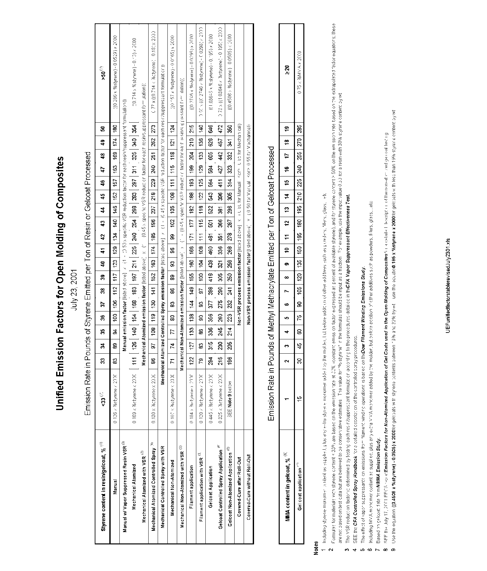
Appendix 4A. UEF

Appendix 4B. Table 1

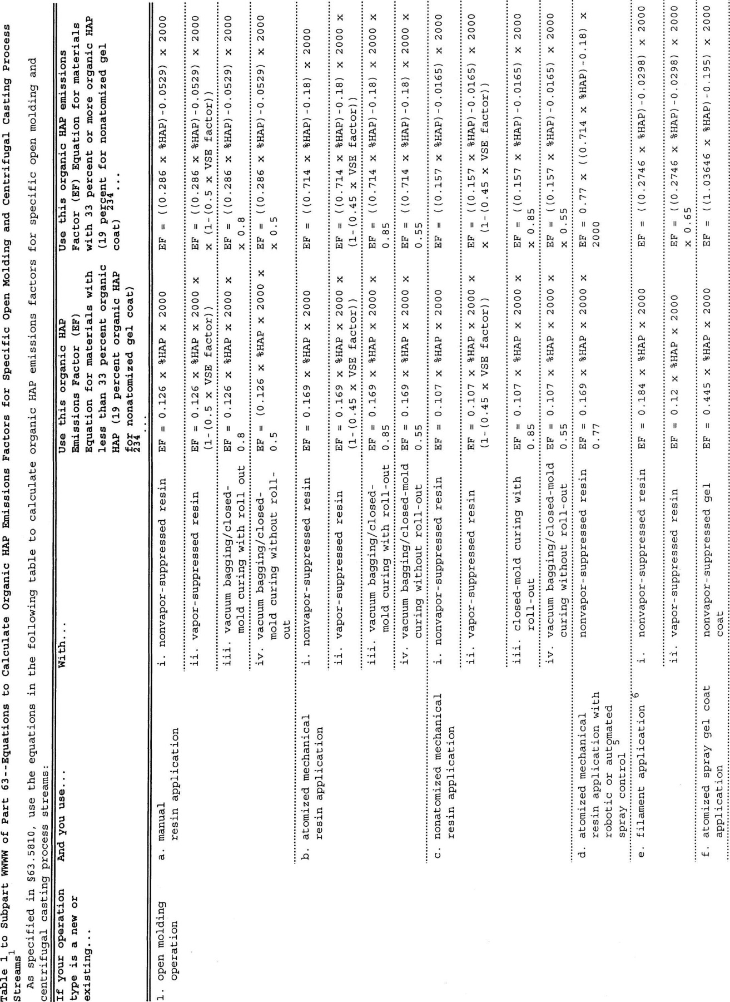

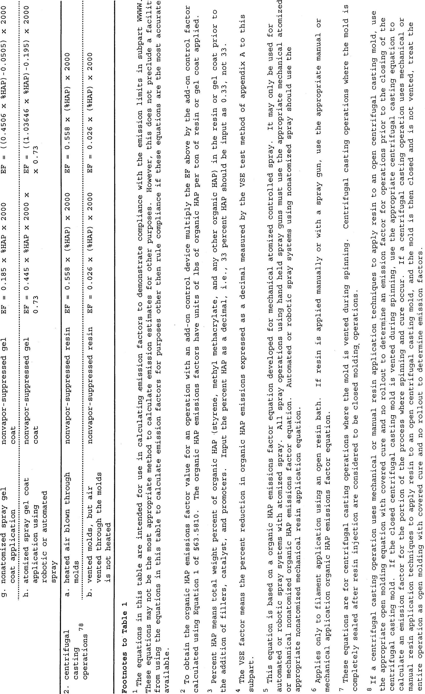

Appendix 4C. Table 2

TABLE 2
Monthly Recordkeeping for 40 CFR Part 63, Subpart WWWW (FGNESHAP WWWW)
Permittee may choose to use the following table in order to show compliance with 40 CFR Part 63, Subpart WWWW

Resin | Month/Year | Organic HAP Content | Emission Factor* (lb/ton)
Gel Coat | Month/Year | Organic HAP Content | Emission Factor* (lb/ton)
*Use the emission factor from Table 1 to 40 CFR Part 63, Subpart WWWW (included in this appendix)

Appendix 5. Testing Procedures

There are no specific testing requirement plans or procedures for this ROP. Therefore, this appendix is not applicable.

Appendix 6. Permits to Install

The following table lists any PTIs issued or ROP revision applications received since the effective date of the previously issued ROP No. MI-ROP-N5599-2017. Those ROP revision applications that are being issued concurrently with this ROP renewal are identified by an asterisk (*). Those revision applications not listed with an asterisk were processed prior to this renewal.

Source-Wide PTI No MI-PTI-N5599-2017 is being reissued as Source-Wide PTI No. MI-PTI-N5599-2022.

Permit to Install Number | ROP Revision  Application Number | Description of Equipment or Change | Corresponding Emission Unit(s) or  Flexible Group(s)
NA | NA | NA | NA

Appendix 7. Emission Calculations

The permittee shall use the calculations shown in Appendix 4 in conjunction with monitoring, testing or recordkeeping data to determine compliance with the applicable requirements referenced in FGBOOTHSUMMARY Flexible Group Conditions.

Appendix 8. Reporting

A. Annual, Semiannual, and Deviation Certification Reporting

The permittee shall use EGLE, AQD, Report Certification form (EQP 5736) and EGLE, AQD, Deviation Report form (EQP 5737) for the annual, semiannual and deviation certification reporting referenced in the Reporting Section of the Source-Wide, Emission Unit and/or Flexible Group Special Conditions. Alternative formats must meet the provisions of Rule 213(4)(c) and Rule 213(3)(c)(i), respectively, and be approved by the AQD District Supervisor.

B. Other Reporting

Specific reporting requirement formats and procedures are detailed in Part A or the appropriate Source-Wide, Emission Unit and/or Flexible Group Special Conditions. Therefore, Part B of this appendix is not applicable.

